Please provide as much information as possible as it would help us evaluate the submission better.

Product/Idea

* **What is the problem you are trying to solve?**

**(Do you have any supporting statistics from reliable sources, if so please do share.)**

Intruder detection and user authentication while online meet.

We are creating a meet app which provide the facility of creating a online meet and also helps in maintaining the decorum of the meet ( by detecting intruder and taking necessary steps after detecting it ).

CHART ON MENTAL HEALTH

* 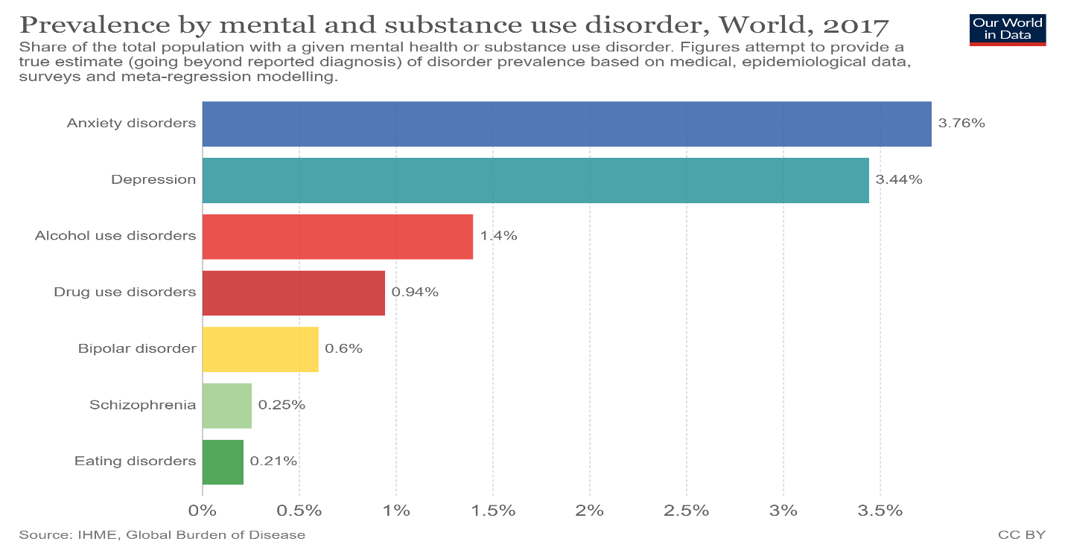
* **How does your idea address the problem?**

->We are creating a React App which will be connected

with the python backend server.

->We will provide host the ability to create/schedule meetings and invite the participants by the meeting link or code and the participants will be authenticated by the password/otp and the email.

->During the meeting there will be the live transcripts of all the participants which will be monitored by the python backend server, the server will identify offensive behaviour and report it to back to the host and also provide participants ability to report the miscreant host/other participants which will be further reported to the admin.

->All the recordings of the meeting will be deleted immediately after the meeting except for the reported conversation and context.

->For the prototype intially we are implementing for support only english language but for the final submission we will implement multi lingual model which will be better suited for India.

* **Who are the target customers?**

->Schools, colleges, seminar organizers, online meetups, online events, live streams and all forms of online events where people may behave poorly are the intended customer base

->Social meetups - online meetups or gathering suffer this problem hence they are good source of revenue

* **What makes your idea unique?**

->Most video platforms are focused on the paid model where only authorised people can participate and issues of cyber-security is not a big concern.

->They focus on adding new features like chat rooms and text message, which they can market and make money from.

->But our product will majorly focus on to improve audio/video quality , provide a better UI/UX to end-user and a good authentication system.

-> We focus on user mental health , user surrounding which is the most vital factor for a successful meet.

* **Do you have a revenue generation model? If so please do share.**

->there are around 1.5 Million schools & 122 thousands  companies in India which could be potential buyer of our platform.

->If we charge around 500 rupees for the 1 month model  then around 80 crore rupee would be our revenue for 1 month.

* **What are the geographies, do you think the idea would be suitable for?**

Entire world , as after covid everything is shifted to online mode and every one are suffering from mental issues due to miscreant behaviour in meeting.

* **What are the risks associated with your idea and how can you mitigate it?**

Our product is entirely based on , how well our cnn and nlp model would classify the intruder . So creating a good model is one of the major challenge .

We also want that our model supports multiple language , so that also a major challenge.

* **Who are the stakeholders involved in order to take bring this idea/product/service to the market?**

**(Ex: State govt, Department of trade and taxes, pollution control board, Manufacturers)**

Department of Education , manufactures and private VCs.

Intellectual Property Assessment

* **Is your idea patentable or patented?**

**(If so please provide details)**

No

* **Is your idea built existing work? If so how is it different?**

->In this we are creating a meet which is already implemented by various org but we also take of the decorum of the meet which is being the most important problem and which is untouched by all the existing apps.

->Our model main moto is to take care of the user. User mental health is the biggest concern in the future.

->We not only make our user happy by the great UI but also with great surrounding

We maintain the surrounding of the user so that he or she can focus on there work , not on the nuisance.

Prototype/ Proof of Concept

* What is the nature of the prototype/ proof of concept, you would be able to submit?

(Ex: Github repository, Hardware prototype)

<https://github.com/GouravSingal-code/sih_project>

* Have you completed pilot tests for your prototype/POC? If so please share.

We have shown the classification of text , whether the language used in text is foul or not

<https://www.youtube.com/watch?v=aBmWrpe7-50>

* What is the approximate cost of developing the prototype?
  + Under 5000 rupees
* Please share the relevant elements while submitting the POC/ Prototype
* Block diagram
* Software Architecture- Control/Data flow
* Block Diagram of Data Flow
* Hardware architecture
* Components/ Connectors
* CAD models
* Visual/Touch Interface
* (Mechanical actuators/switches, touch sensitivity, haptics)

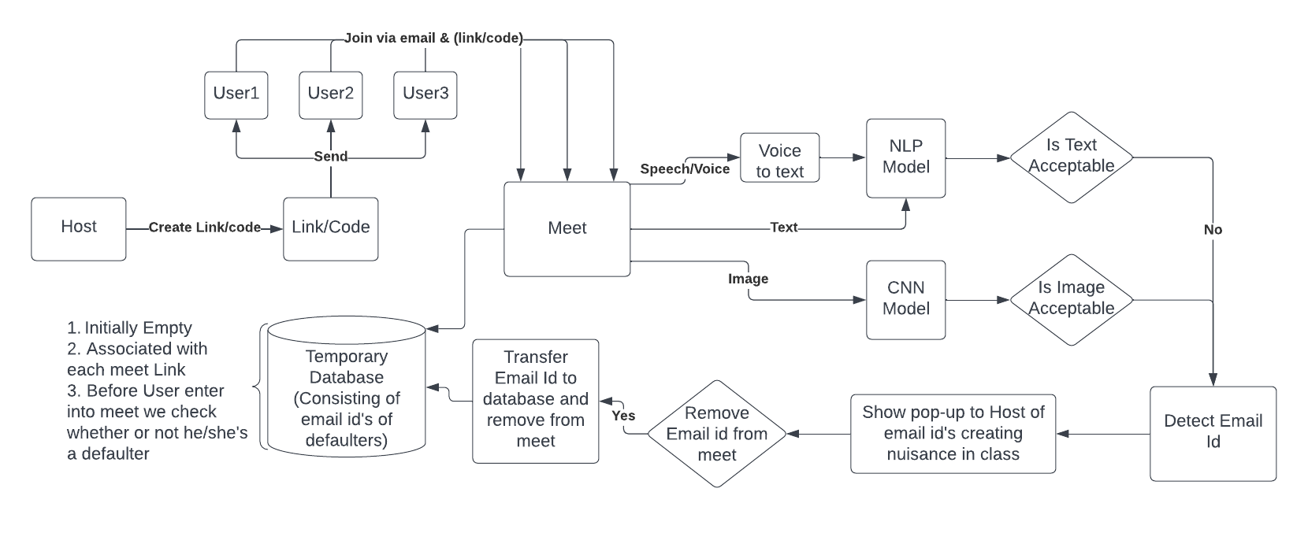

Supporting details

* **What regulatory requirements have to be met to bring the idea to life?**
  + Money
  + Advertisement expertise
* **Do you have a business plan/ commercialization strategy? If so please share.**

After completing the model , we will first contact to different board of education in our country to adopt this model

We will try to get funding , so that , we can do marketing campaign and reach to many many people.

We will explicitly went to some big private companies to adopt this model , as if they adapt it , then other companies also adopt it.

* **What is rough estimate of manufacturing/operational costs?**

->10 – 20 lakhs

* **What is volume of products/ amount of revenue do you expect to make in the first year?**
  + We think schools will adapt this model very quickly , so in a year out of 1.5 million schools approx 1 lakh schools will definitely adopt this model.
  + In case of private companies or ventures approx 1000~